Microsoft Word Template for Papers for 12AHMTC
First Author1∗, Second Author1 and Third Author2
1 University of Sydney, 2 University of Auckland
∗mailto: author.author@sydney.edu.au

Abstract
Include a brief abstract here.

Introduction
Papers submitted to the 12th Australasian Heat and Mass Transfer Conference are to be formatted in accordance with this template. Papers which do not conform to this style will not be published. The font size is 12pt for the main text, and 11pt for the references list.

Submission
Papers are to be submitted as a PDF by email to 12ahmtc.conference@sydney.edu.au with the single word Paper as the subject.

Page Limits
Papers should be 6 to a maximum of 8 pages.

Section Headings
Section and

  - Subsection
headings should be in lower case with the first letter of major words in upper case. Do not use subsubsections.

Figures and Tables
Figures and tables are centred in the column of text, and the width should not exceed the width of the text column. Text in tables and figures should be no smaller than font size 10. Figures and tables must be sequentially numbered and labelled. Figures should be referenced in the text as figure(s), only capitalised at the start of a sentence, and similarly for tables. Colours may be used in both figures and tables as shown in figures 1(a) and (b).

(a)

(b)
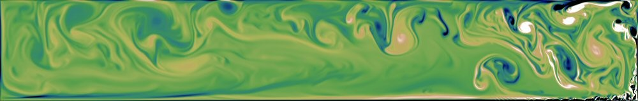
Figure 1. This figure and its caption are centred.

Equations
Equations will be centred with a number flush against the right margin as in
$ρC_{p}\frac{∂T}{∂t}=S-k\frac{∂^{2}T}{∂x^{2}}$, (1)
and this equation would be referred to as “equation (1)”, or as “(1)”. The word equation should only be capitalised at the beginning of a sentence.

Miscellaneous
- Try to avoid isolated lines of text where, for example, a paragraph spills over a page. Often a slight rewording resolves the problem.
- Avoid wasted white space around figures or a last page that is almost empty.
- Use quotation marks correctly, as in “correct”, not ”incorrect”.
- Use a hyphen (-) for compound words (two-dimensional), an en-dash to link numbers, nouns or names (Navier–Stokes, pages 27–85), and an em-dash to link clauses or sentences—like this.
- Use a × to represent multiplication in text, not x.
- Resist the temptation to use footnotes.

Format for References
The references are listed in alphabetical order (by first author) and formatted as shown by the examples at the end of this paper. They may be referred to by the reference number alone or by the author(s) together with the reference number as in “ [2] is a book, [3] is an article in a proceedings, [4] is an edited book, and reference Cooley and Tukey [1] is an article in a journal.” Multiple citations should be written as [2, 4].

Conclusions
You should include a brief conclusion section which summarizes the results of your paper.

Acknowledgements
Any acknowledgements should appear immediately before the references.

REFERENCES
- Cooley, J.W. and Tukey, J.W., An Algorithm for the Machine Computation of Complex Fourier Series, Math. Comp., 19, 1965, 297–301.
- Goosens, M., Mittlebach, F. and Samarin, A., The LATEX Companion, Addison–Wesley, 1994.
- McCormick, S., Multilevel Projection Methodology, in Computational Techniques and Applications: CTAC93, editors D. Stewart, H. Gardner and D. Singleton, World Scientific, 1994, 54–57.
- Rosenhead, L. editor Laminar Boundary Layers Oxford, Clarendon Press, 1963.

